|  |  |  |  |  |  |  |
| --- | --- | --- | --- | --- | --- | --- |
| Ramaiah Skill Academy | | | | | | |
| Program | VLSI SOC Design | | | | Embedded System Design | |
| Batch | Goodwill | | | | Course Start Date | 16/10/2024 |
| Assignment No. | 1 | | Assignment Submission Date: | | | 20/10/2024 |
| Trainee Name |  | | | | | |
| Register No. |  | Email-Id | |  | | |
| Program Leader(s) |  | | | | | |

|  |  |  |
| --- | --- | --- |
| Provide details of team members if assignment work is done by a team | | |
| Register No. | Name of the Trainee | Email -ID |
| VLSI06 | Chandan B K | Chaithra7204@gmail.com |
|  |  |  |
|  |  |  |
|  |  |  |

| To Be Filled by the Faculty Members | | | | | |
| --- | --- | --- | --- | --- | --- |
| Sections | Marking Scheme | | | `Marks | |
| Max | Examiner |
| Part-A | A.1 | Introduction to the Problem Statement | |  |  |
| A.2 | Envisaged Outcomes | |  |  |
| A.3 | Relevance of the Problem | |  |  |
| Sub-Total | | |  |  |
| **Part-B** | B.1 | Proposed Solution / Approach -1 | |  |  |
| B.2 | Proposed Solution / Approach -2 | |  |  |
| B.3 | Proposed Solution / Approach -3 | |  |  |
| Sub-Total | | |  |  |
| Part-C | C.1 | | Description of work done in the identified paper/article |  |  |
| C.2 | | Merits and methods of work done in the identified paper |  |  |
| C.3 | | Gaps or limitations of the work and methodology in the identified paper |  |  |
| C.4 | | Possible solutions to overcome gaps in the work done |  |  |
| C.5 | | Relationship of work done to the problem statement |  |  |
| C.6 | | Adoption of work done to solve problem statement |  |  |
| C.7 | | Novelty and Difference in developed solution as compared to work done in identified paper |  |  |
| Sub-Total | | |  |  |
| Part -D | C.1 | Methods and Methodology/process adopted for solving the problem | |  |  |
| C.2 | Algorithms, Hardware and Software models developed | |  |  |
| C.3 | Testing and Evaluation | |  |  |
| C.4 | Results obtained and inferences drawn | |  |  |
| C.1 | Importance and Social Relevance of the work done | |  |  |
|  | **Sub-Total** | |  |  |

| Sections | Marking Scheme | | `Marks | |
| --- | --- | --- | --- | --- |
| Max | Examiner |
| Part-E | E.1 | Justification of the solution methodology, |  |  |
| E.2 | Justification of the algorithm and coding method used; results obtained |  |  |
| E.3 | Justification of hardware and software tools used solution obtained |  |  |
| Sub-Total | |  |  |
| **Part-F** | F.1 | Flow charts and Block Diagrams |  |  |
| F.2 | Pseudo Codes |  |  |
| F.3 | Graphs and Tables |  |  |
| F.4 | Any other relevant information |  |  |
| Sub-Total | |  |  |
| Grand Total | | |  |  |

**Please note:**

1. Documental evidence for all the components/parts of the assessment such as the reports, presentation slides, posters, laboratory exam tool tests, tutorials, case studies are required to be attached to the assignment report in proper order.
2. The marks for all the questions of the assignment have to be written only in the boxes provided in the table**.**

**Instructions to students:**

1. The assignment consists of 6 parts.
2. The assignment has to be neatly word-processed as per the prescribed format.
3. The maximum number of pages should be restricted as mentioned in each part of the assignment
4. Use only SI units.
5. **Submission Date:**
6. **Submission after the due date is not permitted.**
7. Method of evaluation as per the submission and marking scheme

**NOTE**: All the sources used in preparation for the assignment must be suitably referenced in the text.

#### ASSIGNMENT

#### Part- A: Problem Statement

**Signal Generator and Visualizer (Python) Problem Statement:** To Build a Python program that generates basic waveforms (sine, square, and triangular) and plots them using Matplotlib. Users should be able to control parameters like frequency, amplitude, and phase.

**Tasks to Collaborate on:**

Team 1: Implement waveform generation logic Team 2: Develop the plotting and visualization module Team 3: Create the README and a user guide with example inputs Outcome: An easy-to-use signal generator hosted on GitHub, demonstrating teamwork and programming skills

#### Part- B: Proposed Solution

#### To address the problem of generating and visualizing sine, square, and triangular waveforms, the following solution is proposed:

#### Use Python with Essential Libraries:

#### NumPy will be used to generate the time arrays and perform the mathematical operations required for waveform generation.

#### SciPy's signal module will be employed to generate the square and triangular waves using built-in functions for efficient signal creation.

#### Matplotlib will be used to plot the generated waveforms for visualization, ensuring the wave shapes are clearly represented.

#### Part- C: Nearest Neighborhood Paper

The codes are mostly generated from AI platforms and codes are executed using Python Jupiter and Google Collab.

**Part- D: Activities carried out**

The activities were carried out with a group of 5 members were implemented in GITHub with each person collaborating in different aspects and working towards the project.

**Part- E: Design Your Evaluation**

This solution is optimal because it combines simplicity, flexibility, and efficiency. By utilizing Python's NumPy, SciPy, and Matplotlib libraries, we ensure precise waveform generation and clear visualization. These libraries are lightweight and highly optimized for numerical and signal processing tasks, making them ideal for this project.

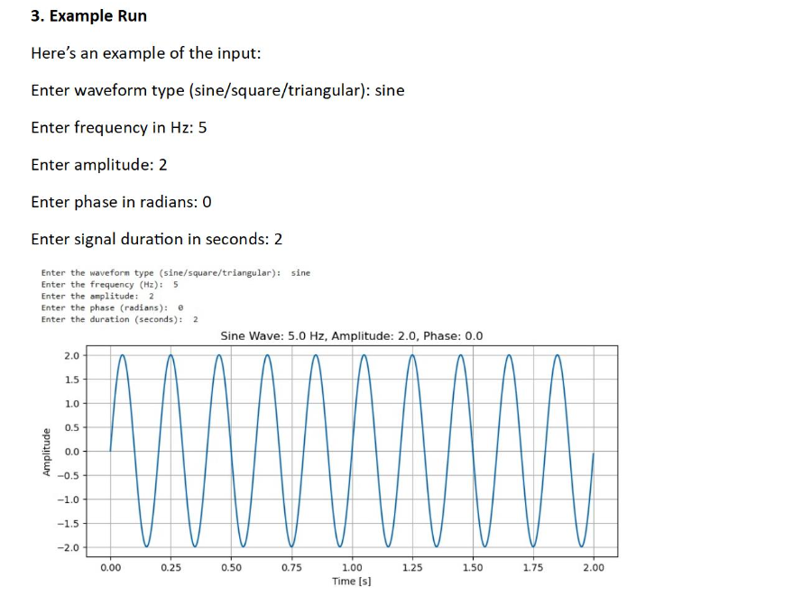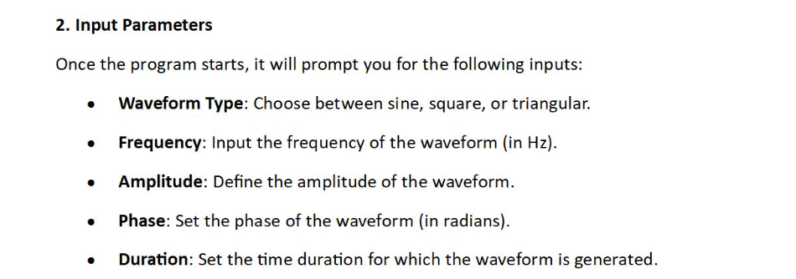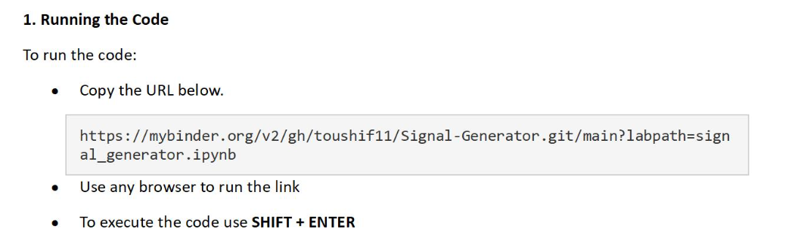**Part- F: Visual Elements**